**Optimizers:Hill descent in 3D and contours**

Below image shows the 3d contour now we can draw contour from this on 2d by taking all the points of same height(of same loss) and draw it in 2-d whatever its shape is.

In below plot x is w1, y is w2 and z is loss.

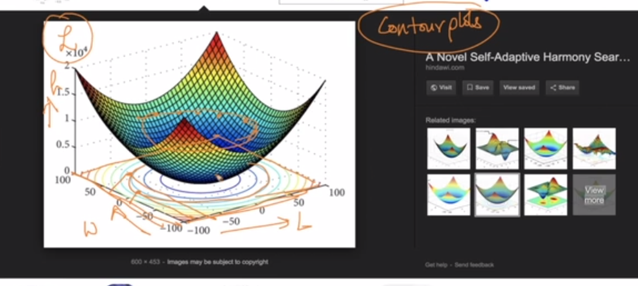

Below pics shows some contour plots

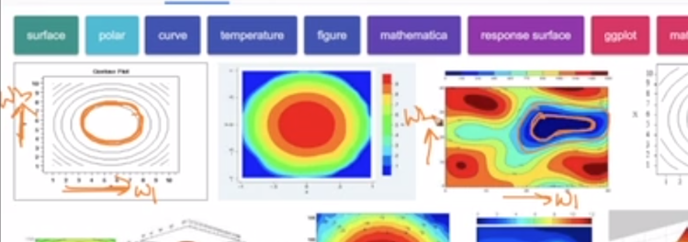

Contour plot of non-convex function is shown below it have many local minima which is shown by dot in contour plot.

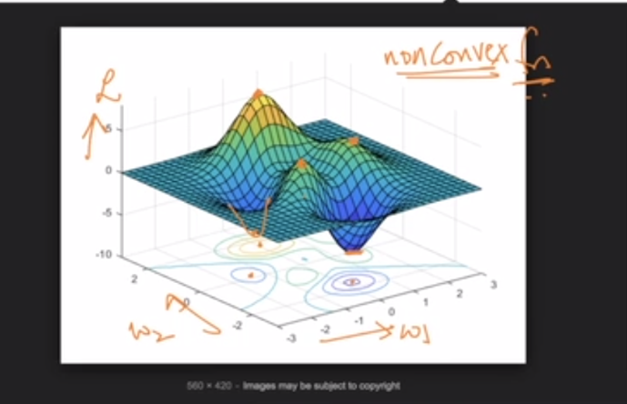

In below contour dot show minima

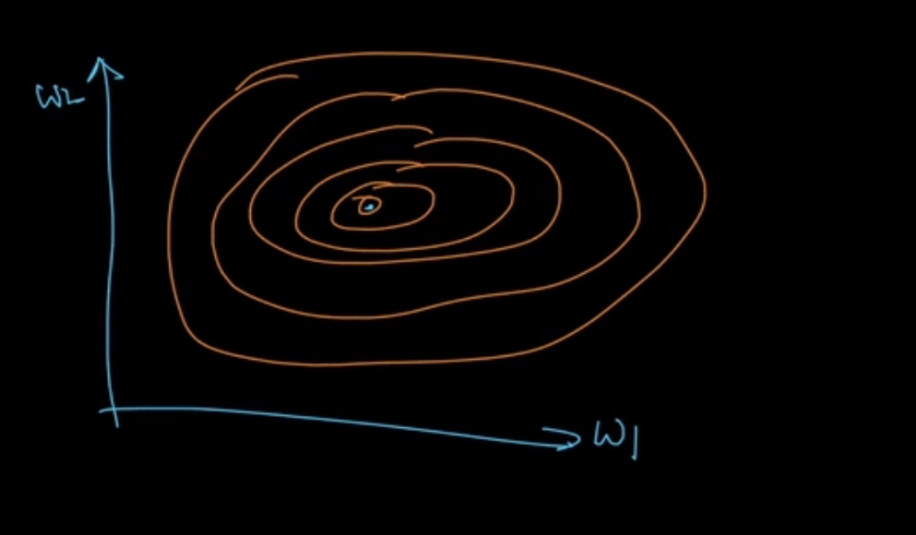

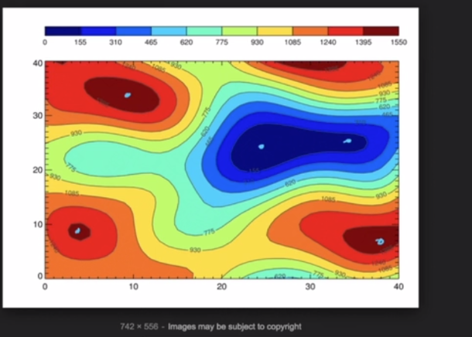

Below plot also shows value of z-axis i.e loss on that height

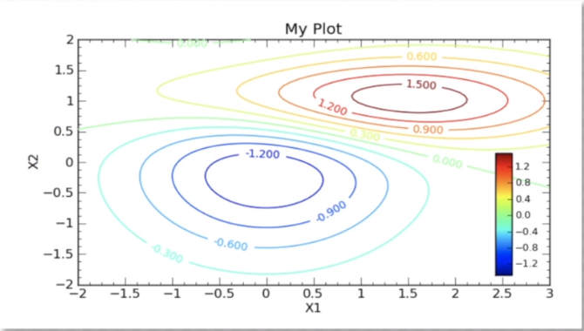

Below pic shows about saddle point here there is no maxima nor minima point, if we look it or cut it from x-axis it seems as a maxima, if we look it or cut it from y-axis it seems as a minima

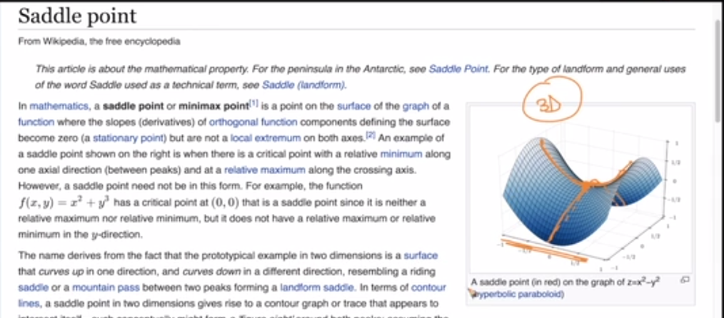

Now in contour plot saddle point is view by two points intersecting each other and this intersecting point is saddle point.

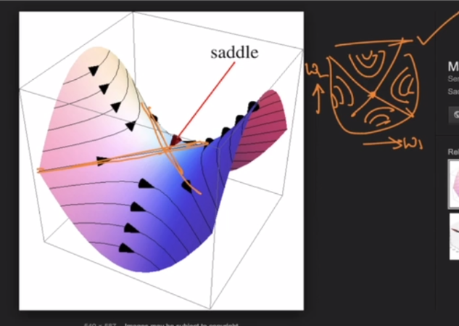

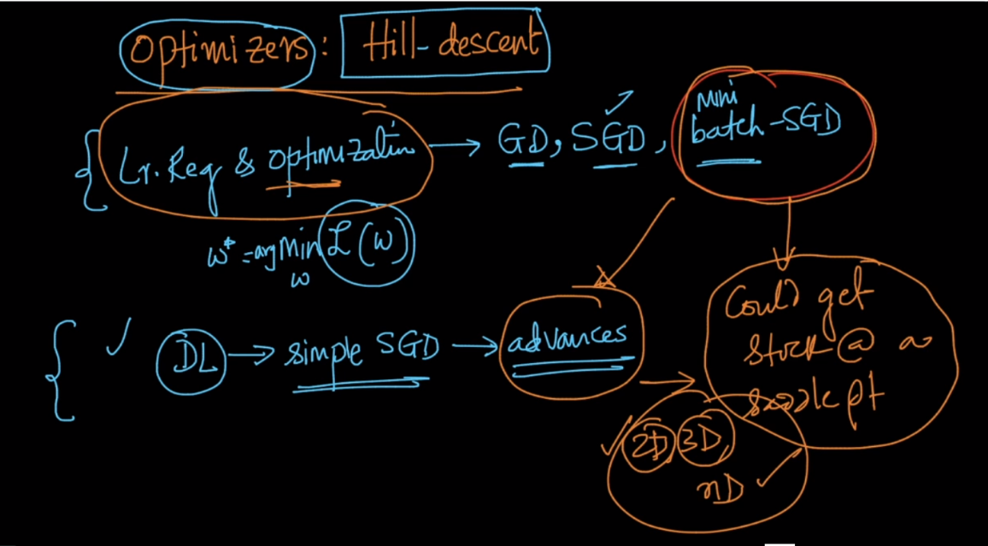

Most simple example of saddle point is f(x) = x3 at x = 0 it is neither minima or not maxima

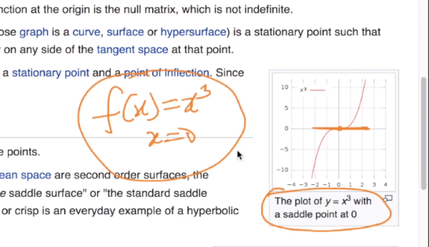

**Comments :**

